**Task-1**

1. Install Jupyter notebook and run the first program and share the screenshot of the output.

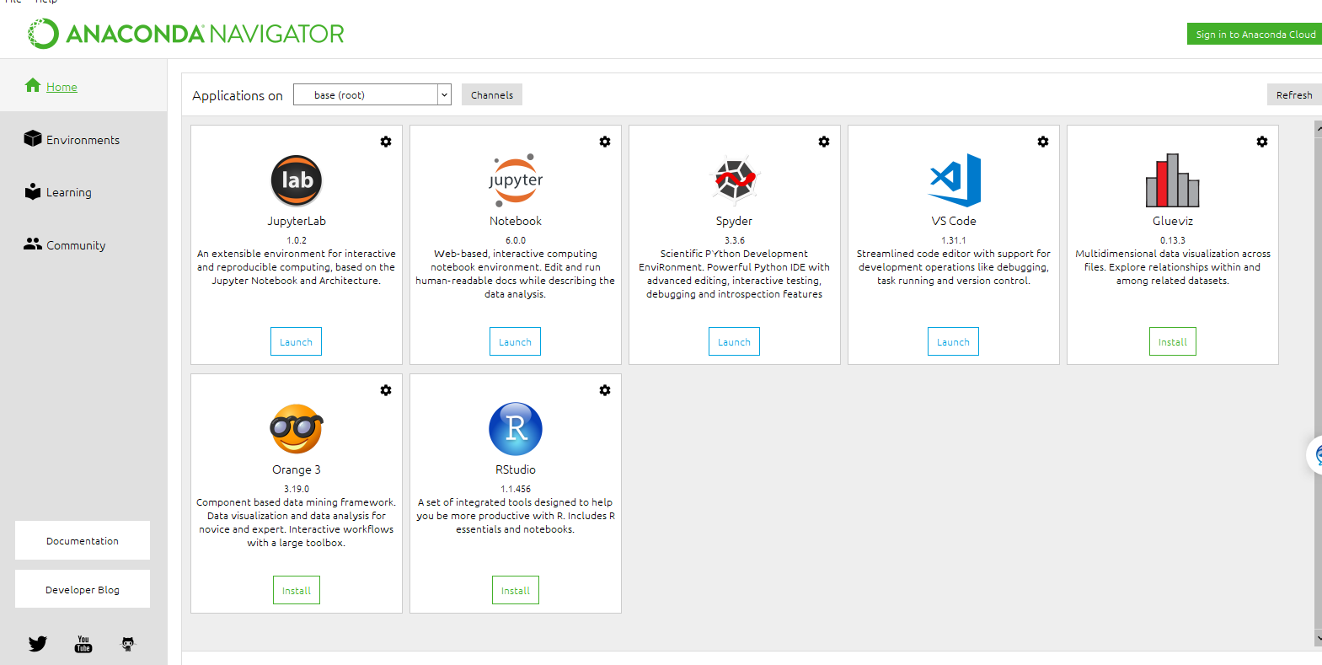

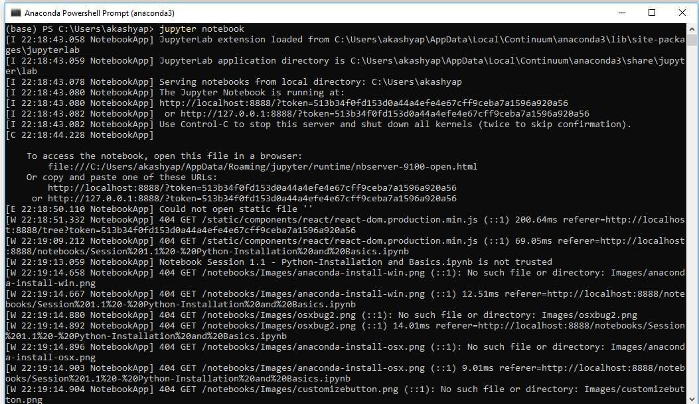

**Programme on jupyter notebook, WAP to check if a given string is pallindrome or not?**

